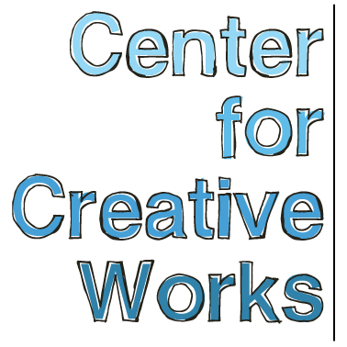

JENNY GARRITY

SELECTED EXHIBITIONS
2017
You and Me, The Philadelphia Foundation, Philadelphia, PA
Drawn to Stitch, Ageless Gardens, Philadelphia, PA
2016
Eloquent Mark, Gallery 241, Wynnewood, PA
You/Me/Them: People in Pictures, Main Line Unitarian Church, Devon, PA

BIO
On any given day, Jenny Garrity (b. 1979) will invariably be found drawing, seated with her nose so close the surface of the page it seems as if she herself is emerging from it, part of the family of gnome-like figures she creates. With delicate, hair-thin lines, forms develop from the accumulation of mark, each topped with a domed, bald head and faint facial features, full of expressive force. In her own private, self-contained way, Garrity has conversations with these little communities she creates, often seeming to chat with them while they come to life, populating her page.

___________________________________________________________________
Center for Creative Works is an art studio for adults with developmental disabilities, located in Wynnewood, PA. We are a non-profit organization under the auspices of Resources for Human Development. Visit our website at www.centerforcreativeworks.org

