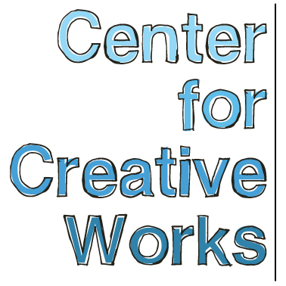

MARY T. BEVLOCK

SELECTED EXHIBITIONS
2018
Person, Place, Thing. University City Arts League, Philadelphia, PA
2017
You and Me, Philadelphia Foundation, Philadelphia, PA
2016
SYMBIOSIS, Haverford College, Bryn Mawr, PA
Perceptions 2016: The Art of Citizenship, Crawford Fine Art Gallery, Cork, Ireland
CORE 12: Defining Ourselves, The Art Exchange, Long Beach, CA
2015
Outside Sound, The Free Library of Philadelphia, Philadelphia, PA
2014
Main Line Wine Gala, Villanova, PA
2013
Saint Louis Outsider Art Fair, Pingle Building, St. Louis, MO

PRESS
Lewis, Alex. Outside Sound connects artists with developmental disabilities and local musicians.
Philadelphia NewsWorks for WHYY / NPR. September 15, 2015.

PUBLIC TALKS
Artist talk, “Race, Identity, and Experience in American Art,” Temple University, October 2017
Artist talk and workshop, Art Education Symposium, Moore College of Art and Design, November 2016

PUBLICATIONS
Father of the Year of God: Portraits of Jesus, The Place Press, Wynnewood, PA
Take Me to the General Hospital Pier, The Place Press, Wynnewood, PA
Psychoanalytic Perspectives: An International Journal of Integration and Innovation,
vol 13 issue 3, 2016
SYMBIOSIS: Art, Science, and Community, Haverford College Press, Bryn Mawr, PA

_________________________________________________________________________________
Center for Creative Works is an art studio for adults with developmental disabilities, located in Wynnewood, PA. We are a non-profit organization under the auspices of Resources for Human Development. Visit our website at www.centerforcreativeworks.org

MARY T. BEVLOCK

ARTIST STATMENT
“Make a picture in your mind of who you want to come to your house and to your dining room. It’s like Thanksgiving, you’re sitting at a table, and you can imagine who you want to come to your house and have dinner. A few of my family, Maurice Benard, my cousin Sally Jeffries, Carmine on Laverne and Shirley. Picasso. Van Gogh.

My inspiration comes from books, shapes, my religion, and celebrities. My favorite material is colored pencils because none of the colors are alike, it feels like butter, with brighter colors. I like to blend because I get more colors that way. It feels great, wonderful, to make artwork, warm and happy feelings. So… magic. Magical. I like response to my paintings, from anybody, that feels really good. “ – MTB

BIO
Mary T. Bevlock was born on July 30th 1968 in Bryn Mawr, PA. She began making artwork at the Center for Creative Works in 2010, when she started making portraits of her favorite celebrities. Bevlock is passionate about advancing herself as an artist, and her work continues to grow in innovative ways as she seeks to develop skills with new materials.

Working from her collection of images of soap opera stars and television actors of the 60’s and 70’s, Bevlock’s goal-oriented approach to art-making is systematized and focused. She begins the day by checking in with her friends and colleagues at the studio diligently preparing her workspace. When she works, Bevlock brings a combination of meticulous rigor and unbound improvisation to her practice. Her passion for color inspires an unexpected and innovative palette, and her detail-oriented mark-making articulates bold, sensitive line. Recently, Bevlock has focused on developing a series of religious portraits in calligraphy ink and colored pencil.

Bevlock likes basketball, weaving, and bowling. Her favorite television shows are CHIPS, General Hospital, Matlock, Happy Days, Laverne and Shirley, and Little House on the Prairie. Mary is also inspired by music, which she listens to on her walkman while drawing and painting, particularly Captain and Tennile, The Carpenters, Kenny Rogers, the Monkees, John Denver, all of Barry Manilow, and Andy Gibb.

_________________________________________________________________________________
Center for Creative Works is an art studio for adults with developmental disabilities, located in Wynnewood, PA. We are a non-profit organization under the auspices of Resources for Human Development. Visit our website at www.centerforcreativeworks.org

