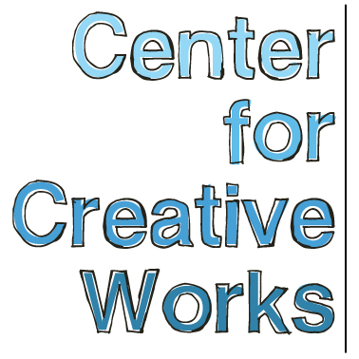

BRANDON SPICER-CRAWLEY

SELECTED EXHIBITIONS
2018
Person, Place, Thing. University City Arts League, Philadelphia, PA
2017
Multiple One, Gallery 241, Wynnewood, PA
2016
You/Me/Them: People In Pictures, Main Line Unitarian Church, Devon, PA
Baked Goods, University City Arts League, Philadelphia, PA
Fantasy Fictions, Ludington Library, Bryn Mawr, PA
Making Waves: Movement and Motion, Wesley Enhanced Living, Media, PA
The Out There Art Fair, Pawtucket, RI
2015
Outside Sound, Free Library of Philadelphia, Philadelphia, PA
In the Woods, Main Line Unitarian Church, Devon, PA
2014
Illuminations, AIR Space Gallery, Philadelphia, PA
2013
Psychadelphia, Pageant:Soloveev, Philadelphia, PA

BIO
A versatile and improvisational artist, Brandon Spicer-Crawley (b. 1980) works with a wide range of material, including wood collage, ceramic, calligraphy ink, paper sculpture, and acrylic paint pen. His style is both free-form and carefully crafted, with recurring motifs of letters, police officers, and squiggly lines. Creating dynamic compositions of abstract shape and figurative forms, Spicer-Crawley develops an electric series of marks emanating outward, creating vibrating, dynamic spaces.

Spicer-Crawley has worked in the studio at CCW since its start in 2011. He lives with his family in Jeffersonville, PA.

____________________________________________________________
Center for Creative Works is an art studio for adults with developmental disabilities, located in Wynnewood, PA. We are a non-profit organization under the auspices of Resources for Human Development. Visit our website at www.centerforcreativeworks.org

