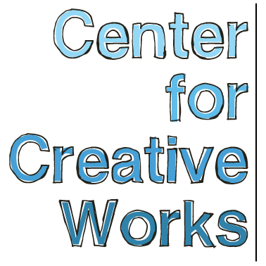

PAIGE DONOVAN

SELECTED EXHIBITIONS
2018
Person, Place, Thing. University City Arts League, Philadelphia, PA
2017
It’s Tuesday All Day Today, High Tide, Philadelphia, PA
You and Me, Philadelphia Foundation, Philadelphia, PA
2016
SYMBIOSIS, Haverford College, Bryn Mawr, PA
Perceptions 2016: The Art of Citizenship, Crawford Fine Art Gallery, Cork, Ireland
Nature in Its Own Form, Gallery 241, Wynnewood, PA
2015
Zeitgeist through Submission, FJORD Gallery, Philadelphia, PA
Art of Exceptionality, Moore College of Art, Philadelphia, PA
Annual, The Scatter Joy Center for the Arts, Horsham, PA
2014
All Different Colors, Fleisher/Ollman Gallery, Philadelphia, PA
Illuminations, AIR Space Gallery, Philadelphia, PA
Saint Louis Outsider Arts, Pingle Building, Fair, St. Louis, MO
2013
Psychadeliphia, Pageant: Soloveev, Philadelphia, PA
Outside Sound, The Rotunda, Philadelphia, PA
The Big Picture, Lankenau Health Center, Wynnewood, PA

PRESS
Lewis, Alex. Outside Sound connects artists with developmental disabilities and local musicians. Philadelphia NewsWorks for WHYY / NPR. September 15, 2015.
Newhouse, Sam, “I’ve Never Seen Anything Like It:” New Fleisher/Ollman show features artists with
developmental disabilities. Metro News, June 10, 2014.

PUBLIC TALKS
Artist talk, “Race, Identity, and Experience in American Art,” Temple University, October 2017
Artist talk and workshop, Art Education Symposium, Moore College of Art and Design, November 2016

_________________________________________________________________________________
Center for Creative Works is an art studio for adults with developmental disabilities, located in Wynnewood, PA. We are a non-profit organization under the auspices of Resources for Human Development. Visit our website at www.centerforcreativeworks.org

PAIGE DONOVAN

PUBLICATIONS
Cred Magazine: October 2013 Issue
My World, The Place Press, Wynnewood, PA
Paige’s Book of Landscapes, The Place Press, Wynnewood, PA
Psychoanalytic Perspectives: An International Journal of Integration and Innovation,
vol 13 issue 3, 2016
SYMBIOSIS: Art, Science, and Community, Haverford College Press, Bryn Mawr, PA

ARTIST STATMENT
“Dots and circles. Details. Straight lines. I like them because they’re different, they pop into my brain and then I know everything about the painting.

I like painting landscapes. It reminds me of going outside in the summertime, and all the different leaves. There’s deer behind our house, they came out of nowhere. There were two or three of them.” – Paige Donovan

BIO
Paige Donovan was born in September 3rd, 1991 in Sycamore Circle in Audobon, PA. She is a swimmer and bocce ball player, and has competed in the Special Olympics for backstroke, freestroke, and breaststroke. She makes artwork at the Center for Creative Works five days a week.

Over the past five years, Donovan has developed an original approach to painting and drawing involving intricately textured marks. Largely focused on landscapes taken both from source imagery and her imagination, Donovan develops a sense of space and distance in her compositions through a dense accrual of small shapes. Her vocabulary of mark comes from a desire to invent new and different ways of manipulating her materials – from crow-quill pen and calligraphy ink to acrylic paint – as well as an almost meditative approach to her art practice, which she continues to hone and develop every day.

_________________________________________________________________________________
Center for Creative Works is an art studio for adults with developmental disabilities, located in Wynnewood, PA. We are a non-profit organization under the auspices of Resources for Human Development. Visit our website at www.centerforcreativeworks.org

