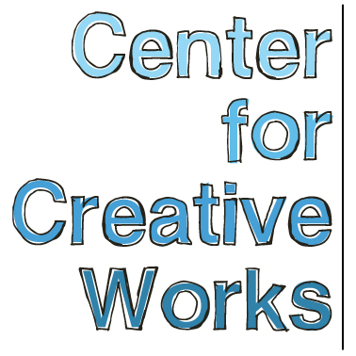

KELLY BROWN

SELECTED EXHIBITIONS
2017
h x d x w, Gallery 241, Wynnewood, PA
Drawn to Stitch, Naudain Street Art Collaborative, Philadelphia, PA
2016
Linear/Nonlinear, Delaware County Community College; Media, PA
2015
Music Library Installation, Free Library of Philadelphia; Philadelphia, PA
Beautiful Water: Sculptures by Kelly Brown (solo), Gallery 241; Wynnewood, PA
2014
St. Louis Outsider Arts Fair: St. Louis, MO
Illuminations, AIRSPACE Gallery, Philadelphia, PA
2013
Psychedelphia, Pageant Soloveev: Philadelphia, PA
Outside Sound, The Rotunda: Philadelphia, PA
A Storm is Coming, Center For Creative Works: Wynnewood, PA
Ludington Library: Bryn Mawr, PA
2012
Color of Art, Grounds For Sculpture: Trenton, NJ
Milkboy Café: Ardmore, PA

PRESS
Jacobs, Melissa. “A Gifted Artist Finds Success, Despite Being Deaf and Blind.” Main Line Today,
Nov 2017.

BIO
Kelly Brown was born in Philadelphia, PA in 1968, with a developmental disability and hearing loss. Her visual abilities have deteriorated progressively since 1991 and she is now almost completely blind, but communicates fluently in sign and sign-through-touch. Brown has worked at the Center for Creative Works since its beginning in 2011. She has developed her weaving practice through practice, intuition, and invention. Without the ability to see, speak, or hear, she has acquired information about making work entirely through touch. For as long as anyone can remember, Brown has worked on crocheting long ropes of yarn, continuing this practice throughout her day both at home and at work.

Finding armatures in dolls and other small household objects, she began creating sculptures

_________________________________________________________________________________
Center for Creative Works is an art studio for adults with developmental disabilities, located in Wynnewood, PA. We are a non-profit organization under the auspices of Resources for Human Development. Visit our website at www.centerforcreativeworks.org

by intertwining her crocheted ropes through and around these shapes. In 2014, Brown was
introduced to a basic frame loom, and began developing weavings through her own invented technique.

Brown’s weavings are created on a basic frame loom, incorporating found textile material that Kelly has collected from the various places in the studio, as well as long threads she has crocheted. Brown uses her entire body to give her information about the work in front of her – hands, arms, feet, tongue – and intertwines found material through the warp of the loom.

In 2016, Brown was introduced to the SAORI weaving technique on a floor loom, an improvisational weaving technique that has allowed her to continue to develop texturally diverse fiber artworks within the matrix of a long, standardized warp. Working with Leslie Sudock of Ready to Hand: SAORI Philadelphia, Brown has developed fabric yardage (which she uses to make her own clothing, operating an antique crankable Singer sewing machine) as well as woven jewelry.

Encountering her pieces once completed and installed, Brown smiles, signs, and laughs as her memory recalls her pieces, like meeting old friends; meandering past the rough and bumpy surfaces, tangling her feet in the tentacle-like strands that extend to the floor, and reaching up to feel the tops.

_________________________________________________________________________________
Center for Creative Works is an art studio for adults with developmental disabilities, located in Wynnewood, PA. We are a non-profit organization under the auspices of Resources for Human Development. Visit our website at www.centerforcreativeworks.org

