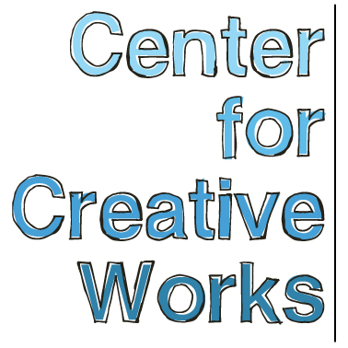

ERIC STEWART

SELECTED EXHIBITIONS
2017
Twilight at the Gardens: Creative Sparc, Philadelphia’s Magic Gardens, Philadelphia, PA
You and Me, Philadelphia Foundation, Philadelphia, PA
2016
Outside Sound, Free Library of Philadelphia, Philadelphia, PA
Me You Them: People in Pictures, Main Line Unitarian Church, Devon, PA
7th Annual Publications and Multiples Fair, Baltimore, MD
Out There Art Fair: 2nd Annual Rhode Island Outsider Art Fair, Pawtucket, RI
2015
In the Woods, Main Line Unitarian Church, Devon, PA
2014
All Different Colors, Fleisher Ollman Gallery, Philadelphia, PA
Illuminations, AIR Space Gallery, Philadelphia, PA

BIO
In his paintings and drawings, Eric Stewart (b. 1990) develops detailed renderings of an eclectic collection of source imagery that blur the line between fantasy and reality. Themes in his work range from art history to archival photographs of agricultural technology from the 1900s. His portrait work emphasizes subtle expressions of posture and mood.
Eric has published three comic books, Spinner on the Block, Bear in the Hood and No Turnin’ Back, the latter is “a story about a 12-year-old Hamilton, a troubled boy who has been abused by his mother and gets caught in a drug gang.” He worked out of Oasis studio in Philadelphia until 2014, when he joined Center for Creative Works.

___________________________________________________________________
Center for Creative Works is an art studio for adults with developmental disabilities, located in Wynnewood, PA. We are a non-profit organization under the auspices of Resources for Human Development. Visit our website at www.centerforcreativeworks.org

