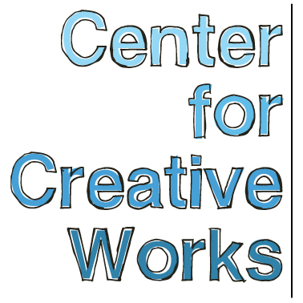

OLIN JOHNSON

SELECTED EXHIBITIONS
2017
Olin Johnson: Signs and Symbols, Green Line, Philadelphia, PA
2016
You, Me, Them: People in Pictures, Main Line Unitarian Church, Devon, PA
Creature Feature, Weird Days, New York, NY
2015
Annual Juried Exhibition, Norristown State Hospital, Norristown, PA
2014
St. Louis Outsider Arts Fair, St. Louis, MO
Illuminations, AIRSPACE Gallery, Philadelphia, PA
Abbottsford Falls Medical Center, Philadelphia, PA
2013
Psychedelphia, Pageant Soloveev, Philadelphia, PA
2012
Outsider: 1, Bluestone Gallery, Philadelphia, PA
Color of Art, Grounds for Sculpture, Trenton, NJ

BIO
Olin Johnson (b. 1968) has been making artwork at CCW for over five years, and before that worked at Oasis art studio. His ever-evolving body of work develops from his intense desire to represent his subject in compartmentalized constructs. Words, animals, shapes, faces all appear in locked formation with specific locations within his compositions. Though the images he creates are skewed and distorted, they are all composed with a specific intent of spatial presence.

____________________________________________________________
Center for Creative Works is an art studio for adults with developmental disabilities, located in Wynnewood, PA. We are a non-profit organization under the auspices of Resources for Human Development. Visit our website at www.centerforcreativeworks.org

