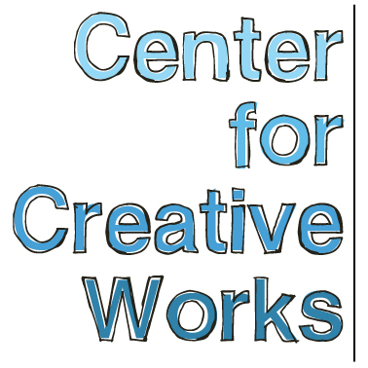

TIM QUINN

SELECTED EXHIBITIONS
2017
Drawn to Stitch, Ageless Gardens, Philadelphia, PA
2016
Eloquent Mark, Gallery 241, Wynnewood, PA
Perceptions 2016: The Art of Citizenship, Crawford Art Gallery, Cork, Ireland
The Out There Art Fair, Pawtuckett, RI
VOX XII: News and Weather, Vox Populi, Philadelphia, PA
SYMBIOSIS , Haverford College, Bryn Mawr, PA
2015
Art of Exceptionality, Moore College of Art and Design, Philadelphia, PA
2014
All Different Colors, Fleisher/Ollman Gallery, Philadelphia, PA
Illuminations, AIR Space Gallery, Philadelphia, PA
Saint Louis Outsider Arts Fair, Pingle Building, St. Louis, MO
2013
Psychadeliphia, Pageant: Soloveev, Philadelphia, PA
Saint Louis Outsider Arts Fair, Pingle Buidling, St. Louis, MO
The Big Picture, Lankenau Health Center, Wynnewood, PA

PRESS
Lewis, Alex. Outside Sound connects artists with developmental disabilities and local musicians.
Philadelphia NewsWorks for WHYY / NPR. September 15, 2015.

_________________________________________________________________________________
Center for Creative Works is an art studio for adults with developmental disabilities, located in Wynnewood, PA. We are a non-profit organization under the auspices of Resources for Human Development. Visit our website at www.centerforcreativeworks.org

TIM QUINN

ARTIST STATEMENT
“On the wall of the warehouse. In my father’s office. Inside my house. I have no clue where. I start with a line that goes all around.” – TQ

BIO
For the past six years, Tim Quinn (b. 1989) has developed a specific, line-oriented approach to composition, developing and expanding his range of mark in relation to different materials. Using a combination of calligraphy pen and ink, metallic pen, and watercolor, Quinn creates beds of mark that build inside and expand back out, revealing and obscuring passages through layering. His process is dictated by methodical line application, which remains consistent regardless the media he works with. Focusing on borders and edging, he works from the outside-in, dividing space into concentric bands or grid-like structures. The titles for his compositions always reference interior spaces and architectural structures.

Quinn works in the studio at CCW four days a week, and at a satellite community studio in Philadelphia one day a week.

_________________________________________________________________________________
Center for Creative Works is an art studio for adults with developmental disabilities, located in Wynnewood, PA. We are a non-profit organization under the auspices of Resources for Human Development. Visit our website at www.centerforcreativeworks.org

