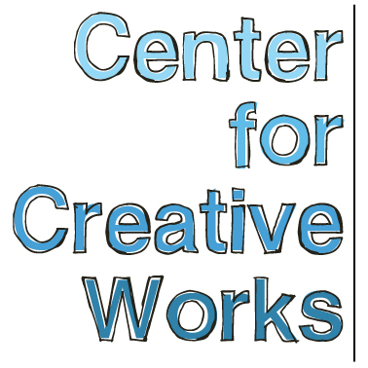

CINDY GOSSELIN

SELECTED EXHIBITIONS
2017
We Do What We Do, Spillway Collective, Philadelphia, PA
h x d x w, Gallery 241, Wynnewood, PA
Drawn to Stitch, Naudain Street Art Collaborative, Philadelphia, PA
2016
Music, Collage, or What? Free Library of Philadelphia, Philadelphia, PA
Creature Feature, Weird Days, New York, NY
2015
Outside Sound, Free Library of Philadelphia, Philadelphia, PA
2014
All Different Colors, Fleisher Ollman Gallery: Philadelphia, PA (Forthcoming)
St. Louis Outsider Arts Fair: St. Louis, MO
2013
Psychedelphia, Pageant Soloveev: Philadelphia, PA
Outside Sound, The Rotunda: Philadelphia, PA
Dear, Stephanie, Center For Creative Works: Wynnewood, PA
The Big Picture, Lankenau Medical Center: Wynnewood, PA
Ludington Library: Bryn Mawr, PA

PRESS
Schwartz, Chip. “We Do What We Do, Spillway Gallery creates an egalitarian space for eighteen artists.” The Art Blog, Aug 19 2017 (web)

BIO
Through a combination of wrapping motions -- spinning, winding, twisting, and dropping – Cindy Gosselin (b. 1964) creates her bound sculptures with a focused, obsessive intensity. Pulling various found objects into the coccoon-like forms, from wooden spools to house keys, they continue to morph and grow until Gosselin deems them “too heavy.” The artist is blind, and her bound vessels are created entirely though her sense of touch.

Aside from her sculpture, Gosselin has a sincere passion for music, and has performed in a number of venues in Philadelphia. She works at the Center for Creative Works five days a week, and has been working there since its founding in 2011.

_________________________________________________________________________________
Center for Creative Works is an art studio for adults with developmental disabilities, located in Wynnewood, PA. We are a non-profit organization under the auspices of Resources for Human Development. Visit our website at www.centerforcreativeworks.org

